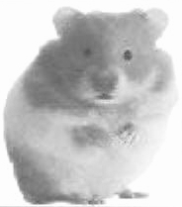
MEMBERSHIP APPLICATION
California Hamster Association (CHA)

Name
^{First Name} ^{Last Name}
Address

^{City} ^{State} ^{Zip} ^{Country (if other than U.S.)}
Please remember that we are predominantly an internet-based club. The vast majority of our correspondence will be done by internet. Please regularly check the club web site for club info.

Telephone ( ) ( )
^{Primary (Home, etc.)} ^{Alternate (Cell, Work, etc.)}
E-mail Address @

Membership: Individual Family
(age 16 years or older) (all living at the same address)
List additional family members:
Name Age (if under 16)
Name Age (if under 16)
Note: Annual local membership in CHA is $10. For details on membership, please see our website at www.geocities.com/CalHamAssoc. Please make checks payable to Linda Price.
What hamsters do you have and how many:
Syrian (full size/ Dwarf Other
^{”teddybear”)} Campbell’s Winter White
other not sure
I don’t have any hamsters yet... but I want to, right away!

Do you breed hamsters? No Yes
If not, are you planning to in the near future? No Yes Don’t know yet
Do you have your own hamster related Web Site? www.

In what way can you volunteer to help with club activities?

Mail application to: California Hamster Association, 23651 Dune Mear, Lake Forest, CA 92630

